Employee Attendance Dashboard 2025

PROJECT OVERVIEW
The Employee Attendance Dashboard 2025 is an interactive Power BI report designed to analyze and visualize employee attendance, overtime, permissions, and salary-related metrics for better workforce management.

Key Purpose
To provide HR and management with a single-view attendance intelligence system that helps monitor:
- Attendance performance
- Overtime patterns
- Leave & permission usage
- Monthly employee efficiency
- Salary & OT allowance calculations

Dashboard Components

1️. Employee Selector Panel
- A dropdown (List of EMP) to select an employee.
- Dynamic update of all visuals based on selected employee.

2️. Month Filter
- Panel on the left with all 12 months.
- Allows month-wise attendance analysis.

3️. Employee Details Section
Shows the selected employee's:
- Name
- Employee Type/Role
- Employee ID
- Photo

4️. Key Metrics Cards
- OT Hour – Total overtime hours in the selected month.
- Permission Time – Hours of permission taken.
- Salary – Monthly salary or prorated salary.
- OT Allowance – Pay earned from OT hours.

5️. OT By Day (Line Chart)
- Shows daily overtime trend for the selected month.
- Helps identify workload spikes and performance patterns.

6️. Attendance Donut Chart
A circular chart showing:
- Total working days
- Present days
- Absent days
- Late or permission-based shortfall
Easy-to-understand visual summary of attendance behavior.

Insights This Dashboard Provides
- Employee productivity trends
- Attendance irregularity alerts
- Month-wise OT utilization
- Permission/leave patterns
- Workload balance insights
- Support for payroll processing

Benefits
- Helps HR track and validate attendance instantly
- Supports management decision-making
- Reduces manual attendance calculation
- Ensures fair OT payment
- Enhances transparency in workforce analytics

Conclusion
The Employee Attendance Dashboard 2025 provides a powerful, interactive, and visually appealing solution for monitoring employee work patterns. By combining attendance records, overtime data, permission hours, and salary calculations into one unified platform, the dashboard enables HR teams and managers to make faster and more accurate decisions.Its dynamic filters, employee-specific insights, and day-wise visualizations help identify productivity trends, ensure transparency, and improve workforce planning. Overall, this dashboard strengthens organizational performance by transforming raw attendance data into meaningful and actionable insights.
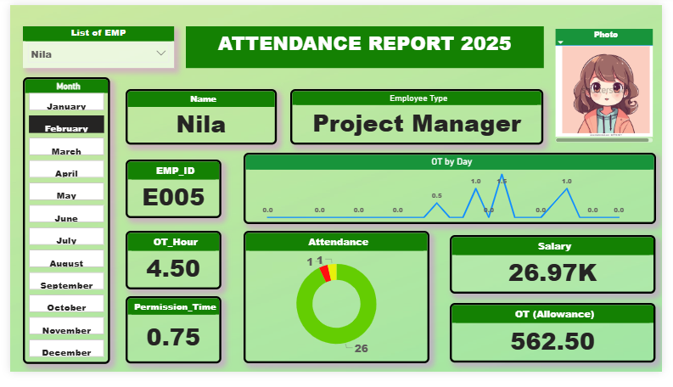
Over View :

